**Strings:**

- A sequence of characters contained within a pair of *‘single quotes’* or *“double quotes”*   
- Can be any length and contain any letters, numbers, symbols, and spaces  
- Can be thought of as a list of characters – each character in a list has an *index position*- Strings are **immutable** and cannot be changed once created (can only create new strings from them)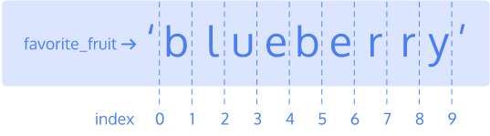

**Substring –** Created when a string is sliced with index positions [first_index:last_index)   
- Last index is not included in return (4:6 only returns “be” **not** “ber”)

*- len() ­*returns the number of characters in a string   
- Also counts spaces in string  
- When trying to determine the last character in a string, use the function **len(variable_name) -1  
-** Can also use to only return last characters in a string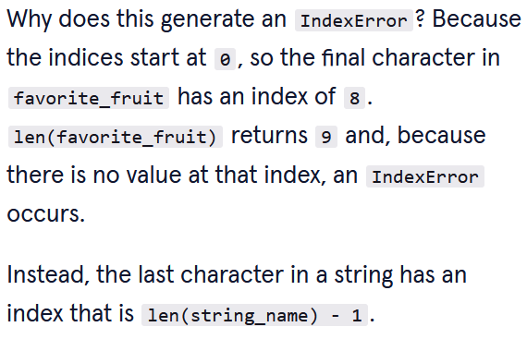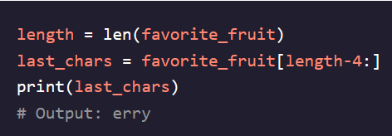

**Escape Characters:**

- Used to include special characters in strings that would otherwise break print statement  
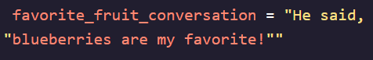 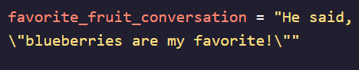

**Iterating Through Strings:**

- Because strings are lists we can iterate through them using *for* and *while* loops  
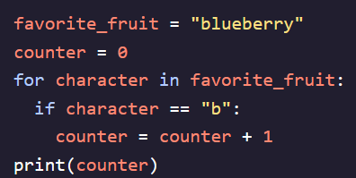

**In Checking:**

- An expression that returns a Boolean value if the condition is True or False  
 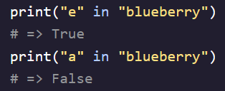

- Works with entire words as well, not just characters  
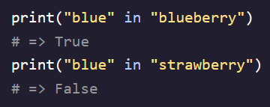

- Can also combine multiple expressions to make even more specific   
